# 

PREDICTION OF CARDIAC ARREST USING ML, AI, DEEPLEARNING, NEURAL NETWORKS AND COMPUTER VISION



Made By: PRATEEK AWATE

VAVILASHETTY VENKAT SAIKUMAR

AVINASH YADAV

In mentorship of: PROF. NISHIKANT SURWADE

# **Chapter 1** **INTRODUCTION**

**The human heart is a finely-tuned instrument that serves the whole body. It is a muscular organ around the size of a closed fist, and it sits in the chest, slightly to the left of center.**

The heart beats around [100,000 times a day](https://www.bhf.org.uk/informationsupport/how-a-healthy-heart-works), pumping approximately 8 pints of blood throughout the body 24/7. This delivers oxygen- and nutrient-rich blood to tissues and organs and carries away waste.

## Anatomy of the heart

The heart consists of [four chambers](https://www.bhf.org.uk/informationsupport/how-a-healthy-heart-works):

* **The atria:** These are the two upper chambers, which receive blood.
* **The ventricles:** These are the two lower chambers, which discharge blood.

A wall of tissue called the septum separates the left and right atria and the left and right ventricle. Valves separate the atria from the ventricles.

The heart’s walls consist of three layers of tissue:

* **Myocardium:** This is the muscular tissue of the heart.
* **Endocardium:** This tissue lines the inside of the heart and protects the valves and chambers.
* **Pericardium:** This is a thin protective coating that surrounds the other parts.
* **Epicardium:** This protective layer consists mostly of connective tissue and forms the innermost layer of the pericardium.

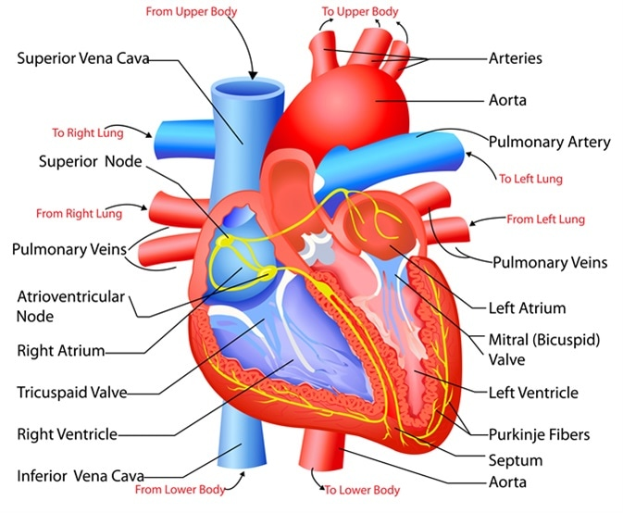

## 1.2 How the heart works

The rate at which the heart contracts depends on many factors, such as:

* activity and exercise
* emotional factors
* some medical conditions
* a [fever](https://www.medicalnewstoday.com/articles/168266.php)
* some medications
* dehydration

At rest, the heart might beat around [60 times](https://www.nhsinform.scot/illnesses-and-conditions/heart-and-blood-vessels/about-the-heart/understanding-how-your-heart-functions) each minute. But this can increase to 100 beats per minute (bpm) or more.

### **1.2.1 Left and right sides**

The left and right sides of the heart work in unison. The atria and ventricles contract and relax in turn, producing a rhythmic heartbeat.

**1.2.1.1 Right side**

The right side of the heart receives deoxygenated blood and sends it to the lungs.

* The right atrium receives deoxygenated blood from the body through veins called the superior and inferior vena cava. These are the largest veins in the body.
* The right atrium contracts and blood passes to the right ventricle.
* Once the right ventricle is full, it contracts and pumps the blood to the lungs via the pulmonary artery. In the lungs, the blood picks up oxygen and offloads carbon dioxide.

**1.2.1.2 Left side**

The left side of the heart receives blood from the lungs and pumps it to the rest of the body.

* Newly oxygenated blood returns to the left atrium via the pulmonary veins.
* The left atrium contracts, pushing the blood into the left ventricle.
* Once the left ventricle is full, it contracts and pushes the blood back out to the body via the aorta.

### **1.2.2 Diastole, systole, and blood pressure**

Each heartbeat has two parts:

**Diastole:** The ventricles relax and fill with blood as the atria contract, emptying all blood into the ventricles.

**Systole:** The ventricles contract and pump blood out of the heart as the atria relax, filling with blood again.

When a person takes their blood pressure, the machine will give [a high and a low number](https://www.heart.org/en/health-topics/high-blood-pressure/understanding-blood-pressure-readings). The high number is the systolic blood pressure, and the lower number is the diastolic blood pressure.

**Systolic pressure:** This shows how much pressure the blood creates against the artery walls during systole.

**Diastolic pressure:** This shows how much pressure is in the arteries during diastole.

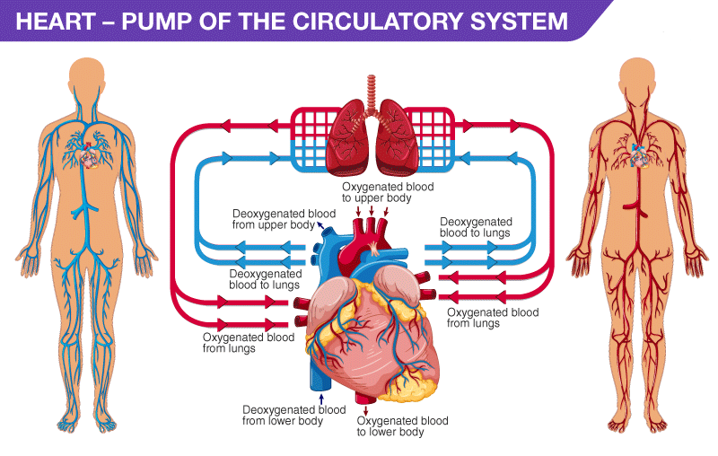

### **1.2.3 Gas exchange**

When blood travels through the pulmonary artery to the [lungs](https://www.medicalnewstoday.com/articles/305190), it passes through tiny capillaries that connect on the surface of the lung’s air sacs, called the alveoli.

The body’s cells need oxygen to function, and they produce carbon dioxide as a waste product. The heart enables the body to eliminate unwanted carbon dioxide.

Oxygen enters the blood and carbon dioxide leaves it through the capillaries of the alveoli.

The coronary arteries on the surface of the heart supply oxygenated blood to the heart muscle.

### **1.2.4 Pulse**

A person can feel their pulse at points where arteries pass close to the skin’s surface, such as on the wrist or neck. The pulse is the same as the heart rate. When you feel your pulse, you feel the rush of blood as the heart pumps it through the body.

A healthy pulse is usually [60–100 bpm](https://www.heart.org/en/health-topics/high-blood-pressure/the-facts-about-high-blood-pressure/all-about-heart-rate-pulse), and what is normal can vary from person to person.  
  
A very active person may have a pulse as low as 40 bpm. People with a larger body size tend to have a faster pulse, but it is not usually over 100 bpm.

[Learn how to take the pulse here.](https://www.medicalnewstoday.com/articles/258118.php)

## 1.2 Valves

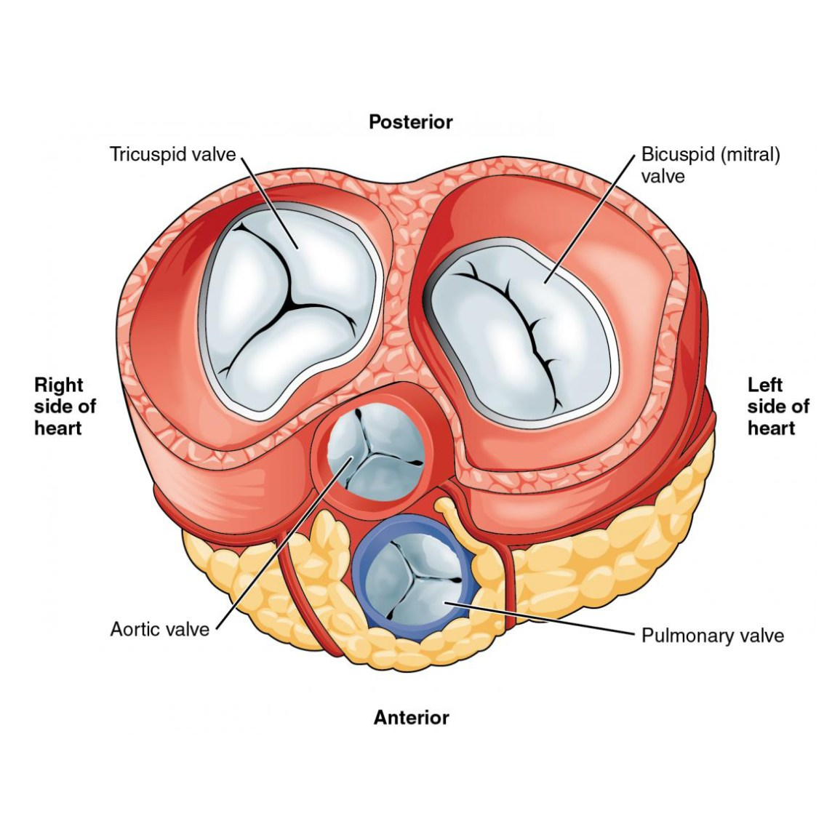Share on Pint **diagram of the heart’s valves**

The heart has [four valves](https://www.heart.org/en/health-topics/congenital-heart-defects/about-congenital-heart-defects/how-the-healthy-heart-works#.WkuuulSFhTY) to ensure that blood only flows in one direction:

* **Aortic valve:** This is between the left ventricle and the aorta.
* **Mitral valve:**This is between the left atrium and the left ventricle.
* **Pulmonary valve:** This is between the right ventricle and the pulmonary artery.
* **Tricuspid valve:** This is between the right atrium and right ventricle.

Most people are familiar with the sound of the heart. The heart makes [many types of sound](https://www.ncbi.nlm.nih.gov/books/NBK541010/), and doctors can distinguish these to monitor the health of the heart.  
  
The opening and closing of the valves are key contributors to the sound of the heartbeat. If there is leaking or a blockage of the heart valves, it can create sounds called “murmurs.”

## 1.3 The heart’s electrical system

To pump blood throughout the body, the muscles of the heart must work together to squeeze the blood in the right direction, at the right time, and with the right force. Electrical impulses coordinate this activity.

The electrical signal begins at the sino-atrial node, sometimes called the sinus, or SA, node. This is the heart’s pacemaker, and it sits at the top of the right atrium. The signal causes the atria to contract, pushing blood down into the ventricles.

The electrical impulse then travels to an area of cells at the bottom of the right atrium, between the atria and ventricles, called the atrioventricular, or AV, node.  
  
These cells act as a gatekeeper. They coordinate the signal so that the atria and ventricles do not contract at the same time. There needs to be a slight delay.

From here, the signal travels along fibers, called Purkinje fibers, within the ventricle walls. The fibers pass the impulse to the heart muscle, causing the ventricles to contract.

**1.4 Heart Conditions**

* [**Stable angina pectoris**](https://www.webmd.com/heart-disease/guide/heart-disease-angina)**:** Narrowed coronary arteries cause predictable chest pain or discomfort with exertion. The blockages prevent the heart from receiving the extra oxygen needed for strenuous activity. Symptoms typically get better with rest.
* [**Unstable angina pectoris**](https://www.webmd.com/heart-disease/guide/heart-disease-angina)**:** Chest pain or discomfort that is new, worsening or occurs at rest. This is an emergency as it can precede a heart attack, serious abnormal heart rhythm, or cardiac arrest.
* **Myocardial infarction (**[**heart attack**](https://www.webmd.com/heart-disease/guide/heart_disease_heart_attacks)**):** A coronary artery is suddenly blocked. Starved of oxygen, part of the heart muscle dies.
* [**Arrhythmia**](https://www.webmd.com/heart-disease/heart-rythym-disorders)**(dysrhythmia):** An abnormal heart rhythm due to changes in the conduction of electrical impulses through the heart. Some arrhythmias are benign, but others are life-threatening.
* [**Congestive heart failure**](https://www.webmd.com/heart-disease/guide-heart-failure)**:** The heart is either too weak or too stiff to effectively pump blood through the body. Shortness of breath and leg swelling are common symptoms.
* [**Cardiomyopathy**](https://www.webmd.com/heart-disease/guide/muscle-cardiomyopathy)**:** A disease of the heart muscle in which the heart is abnormally enlarged, thickened, and/or stiffened. As a result, the heart's ability to pump blood is weakened.
* **Myocarditis:** Inflammation of the heart muscle, most often due to a viral infection.
* [**Pericarditis**](https://www.webmd.com/heart-disease/guide/heart-disease-pericardial-disease-percarditis)**:** Inflammation of the lining of the heart (pericardium). Viral infections, kidney failure, and autoimmune conditions are common causes.
* [**Pericardial effusion**](https://www.webmd.com/heart-disease/guide/pericardial-effusion)**:** Fluid between the lining of the heart (pericardium) and the heart itself. Often, this is due to pericarditis.
* [**Atrial fibrillation**](https://www.webmd.com/heart-disease/atrial-fibrillation/heart-disease-atrial-fibrillation-basics)**:** Abnormal electrical impulses in the atria causes an irregular heartbeat. Atrial fibrillation is one of the most common arrhythmias.
* [**Pulmonary embolism**](https://www.webmd.com/a-to-z-guides/pulmonary-embolism-topic-overview)**:** Typically, a blood clot travels through the heart to the lungs.
* [**Heart valve disease**](https://www.webmd.com/heart-disease/guide/heart-valve-disease)**:** There are four heart valves, and each can develop problems. If severe, valve disease can cause congestive heart failure.
* [**Heart murmur**](https://www.webmd.com/heart-disease/heart-murmur-causes-treatments)**:** An abnormal sound heard when listening to the heart with a stethoscope. Some heart murmurs are benign; others suggest heart disease.
* [**Endocarditis**](https://www.webmd.com/heart-disease/tc/endocarditis-topic-overview)**:** Inflammation of the inner lining or heart valves of the heart. Usually, endocarditis is due to a serious infection of the heart valves.
* [**Mitral valve prolapses**](https://www.webmd.com/heart-disease/tc/mitral-valve-prolapse-overview)**:** The mitral valve is forced backwards slightly after blood has passed through the valve.
* [**Sudden cardiac death**](https://www.webmd.com/heart-disease/guide/sudden-cardiac-death)**:** Death caused by a sudden loss of heart function (cardiac arrest).
* [**Cardiac arrest**](https://www.webmd.com/heart-disease/guide/handling-cardiac-emergencies)**:** Sudden loss of heart function.
* **STEMI: Classic or major Heart Attack:** occurs when a coronary artery becomes completely blocked and a large portion of the muscle stops receiving blood. It’s a serious heart attack that can cause significant damage. STEMI has a classic symptom of pain in the center of the chest. This chest discomfort may be described as a pressure or tightness rather than sharp pain. Some people who experience STEMIs also describe feeling pain in one or both arms or their back, neck, or jaw.
* **CAS, silent heart attack, or heart attack without blockage:** [Coronary Artery Spasm](https://www.healthline.com/health/coronary-artery-spasm)(CAS) is also known as a coronary spasm, unstable angina, or silent heart attack. The symptoms, which can be the same as a STEMI heart attack, maybe mistaken for muscle pain, indigestion, and more. It occurs when one of the heart’s arteries tightens so much that blood flow stops or becomes drastically reduced. Only imaging and blood test results can tell your doctor if you’ve had a silent heart attack. There is no permanent damage during a coronary artery spasm. While silent heart attacks aren’t as serious, they do increase your risk of another heart attack or one that may be more serious.
* **NSTEMI:** Unlike in a STEMI, the affected coronary artery is only partially blocked in an NSTEMI. An NSTEMI won’t show any change in the ST segment on the electrocardiogram. C[oronary angiography](https://www.healthline.com/health/coronary-angiography) will show the degree to which the artery is blocked. A blood test will also show elevated troponin protein levels.

**1.5 The risk factors for different Heart conditions**

* high levels of LDL (“bad”) cholesterol
* high blood pressure
* obesity
* sedentary lifestyle
* smoking
* advanced age
* diabetes
* There are also risks associated with gender. For example, until age 55 or so, men are at a higher risk of a heart attack. After menopause, though, women tend to have similar risks as men. Also, men tend to have problems in the heart’s larger arteries, while women often experience blockage in the smaller arteries of the heart.
* migraines
* excess thyroid hormone
* chronic allergy conditions
* smoking
* excessive alcohol consumption
* low magnesium levels
* taking drugs for chemotherapy

**1.6 Symptoms of Heart Attack**

* upper abdomen
* [shoulder](https://www.healthline.com/symptom/shoulder-pain)
* [back](https://www.healthline.com/health/back-pain)
* neck/throat
* teeth or [jaw](https://www.healthline.com/health/jaw-pain)
* chest pains or tightness or squeezing
* [Sweating](https://www.healthline.com/health/hyperhidrosis) more than usual
* [Night sweats](https://www.healthline.com/symptom/night-sweats)
* [Fatigue](https://www.healthline.com/symptom/fatigue)
* some women may even think their heart attack symptoms are [flu-like symptoms](https://www.healthline.com/health/flu-symptoms).
* Shortness of breath
* [Lightheadedness](https://www.healthline.com/health/lightheadedness) and [dizziness](https://www.healthline.com/symptom/dizziness)
* Heart palpitations
* Indigestion
* nausea
* vomiting

**1.7 Points to be considered for prediction of Heart Attack**

* Age
* Diabetes
* Smoking
* Systolic Blood Pressure (SBP)
* Treatment for hypertension
* Total Cholesterol
* High-Density Lipoprotein (HDL) cholesterol
* The difference in BP while resting and other activities
* Fasting blood sugar
* Resting electrographic results
* Maximum heart rate achieved
* Obesity

**1.8 Heart Tests**

* [**Electrocardiogram**](https://www.webmd.com/heart-disease/electrocardiogram)**(ECG or EKG):** A tracing of the heart’s electrical activity. Electrocardiograms can help diagnose many heart conditions.
* [**Echocardiogram**](https://www.webmd.com/heart-disease/guide/diagnosing-echocardiogram)**:** An ultrasound of the heart. An echocardiogram provides direct viewing of any problems with the heart muscle’s pumping ability and heart valves.
* [**Cardiac stress test**](https://www.webmd.com/heart-disease/guide/stress-test--(dupe))**:** By using a treadmill or medicines, the heart is stimulated to pump to near-maximum capacity. This may identify people with coronary artery disease.
* [**Cardiac catheterization**](https://www.webmd.com/heart-disease/cardiac-catheterization-medref)**:** A catheter is inserted into the femoral artery in the groin and threaded into the coronary arteries. A doctor can then view X-ray images of the coronary arteries or any blockages and perform stenting or other procedures.
* [**Holter monitor**](https://www.webmd.com/heart-disease/guide/electrocardiogram-specialized-ekgs)**:** If a doctor suspects an arrhythmia, a portable heart monitor can be worn. Called a Holter monitor, it records the heart's rhythm continuously for 24 hours.
* [**Event monitor**](https://www.webmd.com/heart-disease/guide/electrocardiogram-specialized-ekgs)**:** If a doctor suspects an infrequent arrhythmia, a portable heart monitor called an event monitor can be worn. When you develop symptoms, you can push a button to record the heart's electrical rhythm.

**1.6 Heart Treatments**

* [**Exercise**](https://www.webmd.com/fitness-exercise/exercise-for-heart-health)**:** Regular exercise is important for heart health and most heart conditions. Talk to your doctor before starting an exercise program if you have heart problems.
* [**Angioplasty**](https://www.webmd.com/heart-disease/treatment-angioplasty-stents)**:** During cardiac catheterization, a doctor inflates a balloon inside a narrowed or blocked coronary artery to widen the artery. A stent is often then placed to keep the artery open.
* [**Percutaneous coronary intervention**](https://www.webmd.com/heart-disease/angioplasty-with-stent-placement-for-heart-attack-and-unstable-angina)**(PCI):** Angioplasty is sometimes called a PCI or PTCA (percutaneous transluminal coronary angioplasty) by doctors.
* [**Coronary artery stenting**](https://www.webmd.com/heart-disease/guide/cardiac-catheterization1)**:** During cardiac catheterization, a doctor expands a wire metal stent inside a narrowed or blocked coronary artery to open up the area. This lets blood flow better and can abort a heart attack or relieve angina (chest pain).
* [**Thrombolysis**](https://www.webmd.com/heart-disease/medicine-clot-busters)**:** “Clot-busting” drugs injected into the veins can dissolve a blood clot causing a heart attack. Thrombolysis is generally only done if stenting is not possible.
* [**Lipid-lowering agents**](https://www.webmd.com/cholesterol-management/guide/cholesterol-lowering-medication)**:** Statins and other cholesterol (lipid) lowering drugs reduce the risk for heart attack in high-risk people.
* [**Diuretics**](https://www.webmd.com/heart-disease/medicine-diuretics)**:** Commonly called water pills, diuretics increase urination and fluid loss. This reduces blood volume, improving symptoms of heart failure.
* [**Beta-blockers**](https://www.webmd.com/heart-disease/beta-blocker-therapy)**:** These medicines reduce strain on the heart and lower heart rate. Beta-blockers are prescribed for many heart conditions, including heart failure and arrhythmias.
* **Angiotensin-converting enzyme inhibitors (**[**ACE inhibitors**](https://www.webmd.com/heart-disease/medicine-ace-inhibitors)**):** These blood pressure medicines also help the heart after some heart attacks or in congestive heart failure.
* [**Aspirin**](https://www.webmd.com/heart-disease/aspirin-therapy)**:** This powerful medicine helps prevent blood clots (the cause of heart attacks). Most people who have had heart attacks should take aspirin.
* [**Clopidogrel**](https://www.webmd.com/drugs/drug-5190-Clopidogrel+Oral.aspx?drugid=5190&drugname=Clopidogrel+Oral&source=1)**(**[**Plavix**](https://www.webmd.com/drugs/drug-5869-Plavix+Oral.aspx?drugid=5869&drugname=Plavix+Oral&source=1)**):** A clot-preventing medicine that prevents platelets from sticking together to form clots. Clopidogrel is especially important for many people who have had stents placed.
* [**Antiarrhythmic medications**](https://www.webmd.com/heart-disease/medicine-antiarrhythmics)**:** Numerous medicines help control the heart’s rate and electrical rhythm. This help prevents or controls arrhythmias.
* [**AED**](https://www.webmd.com/heart-disease/handle-cardiac-emergencies)**(automated external defibrillator):** If someone has a sudden cardiac arrest, an AED can be used to assess the heart rhythm and send an electrical shock to the heart if necessary.
* [**ICD**](https://www.webmd.com/heart-disease/tc/implantable-cardioverter-defibrillator-icd-topic-overview)**(Implantable cardioverter-defibrillator):** If a doctor suspects you are at risk for a life-threatening arrhythmia, an implantable cardioverter-defibrillator may be surgically implanted to monitor your heart rhythm and send an electrical shock to the heart if necessary.
* [**Pacemaker**](https://www.webmd.com/heart-disease/pacemaker-implant)**:** To maintain a stable heart rate, a pacemaker can be implanted. A pacemaker sends electrical signals to the heart when necessary to help it beat properly.

## 1.7 Facts about Human Heart

* The heart pumps around 5.7 liters of blood in a day throughout the body.
* The heart is situated at the center of the chest and points slightly towards the left.
* On average, the heart beats about 100,000 times a day, i.e., around 3 billion beats in a lifetime.
* The average male heart weighs around 280 to 340 grams (10 to 12 ounces). In females, it weighs around 230 to 280 grams (8 to 10 ounces).
* An adult heart beats about 60 to 100 times per minute, and newborn babies heart beats at a faster pace than an adult which is about 90 to 190 beats per minute.

**1.8 Statistics for Cardio Vascular Diseases**

* Cardiovascular diseases (CVDs) are the number 1 cause of death globally, taking an estimated 17.9 million lives each year. Four out of 5CVD deaths are due to heart attacks and strokes, and one-third of these deaths occur prematurely in people under 70 years of age.
* Heart diseases have plagued India as it is now known to be leading cause of death in the country. According to a report by Global Burden of Diseases in 2016, 1.7 million Indians die due to heart disease out of the world 17.3 million deaths
* According to the World Health Organization, 17 million people on an average die due to heart related diseases every year. Out of the 17 million, 3 million dies of cardiovascular diseases (CVDs) that include stroke and heart attacks.
* Ischemic heart disease and stroke are the predominant causes and are responsible for >80% of CVD deaths. The Global Burden of Disease study estimate of age-standardized CVD death rate of 272 per 100 000 population in India is higher than the global average of 235 per 100 000 population. Premature mortality in terms of years of life lost because of CVD in India increased by 59%, from 23.2 million (1990) to 37 million (2010)

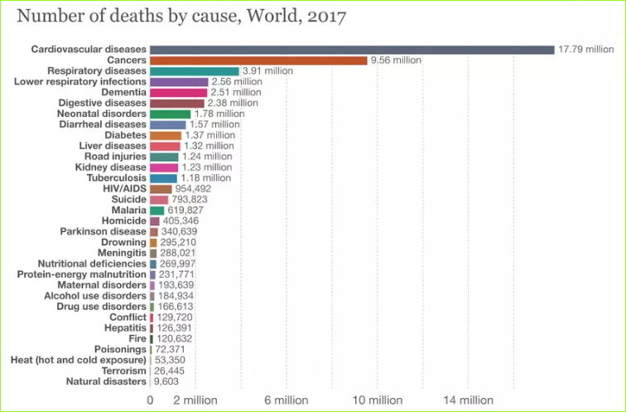

**1.9 Our Motivation for the project**

In today's modern world cardiac arrest is one of the most dangerous disease .In earlier days it was expected to cause only to the old age people above 50 years ,but now as time changed due to the irregular eating habits ,poor diet, smoking, pollution and stress it is seeming to happen even for the person in his/her 20's.Most of the cardiac arrest are silent because of which many of them don't know if it is going to happen or whether it is cardiac arrest or not, because of which many lives are lost every year. It is impractical for a common man to frequently.

undergo costly tests like the ECG and thus there needs to be a system in place which is handy and at the same time reliable, in predicting the chances of a heart disease so we decided to make a project on prediction of cardiac arrest before it happens and by which many lives can be saved

**1.10 Problem Definition**

As there is an increase in problems related to heart, through this project we are going to observe different cardiac issues and habits of people which catalyzes the risk of CVD and predict whether someone is going to have a cardiac arrest and help people to correct their daily habits which pushes them towards the risk of CVD

**1.11 Objectives**

* Extraction of patient information from standard dataset
* Patient information include different attributes such ...
* Data cleaning and preprocessing on those datasets
* Using machine learning algorithms to work on those datasets
* Exploring data analysis
* Predicting whether patient will have cardiac arrest or not